All Orange Areas/Components:

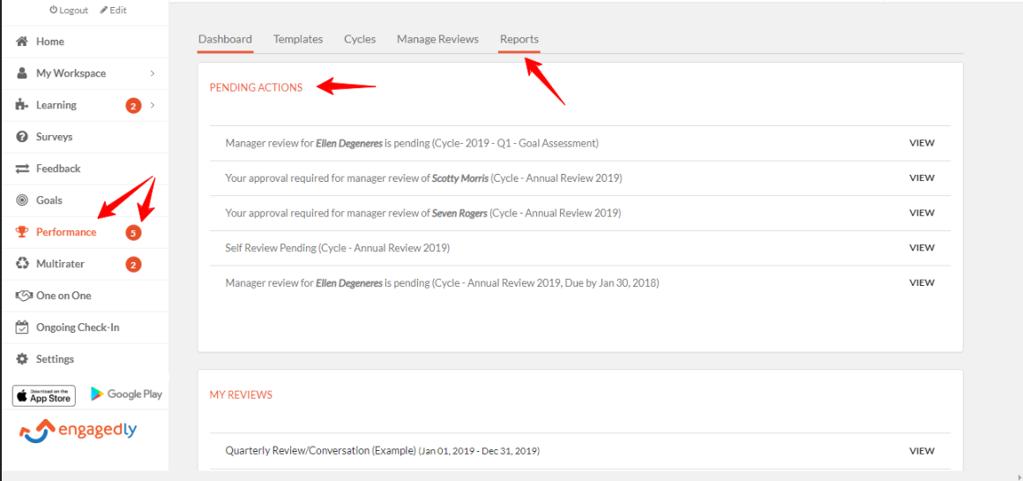

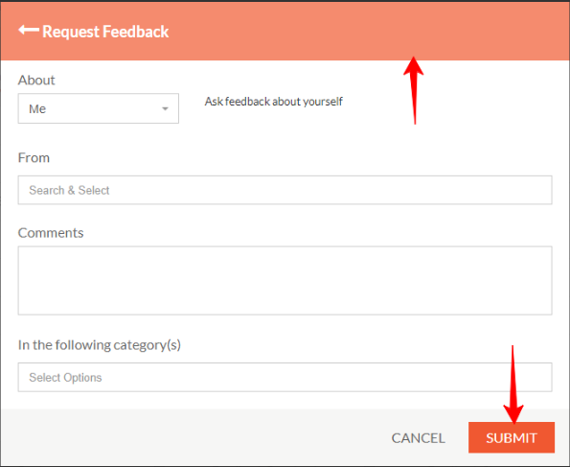

Current Color Hex Code: #E5502A
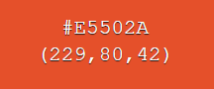

Required Color Hex Code: ????

Site Background Color:

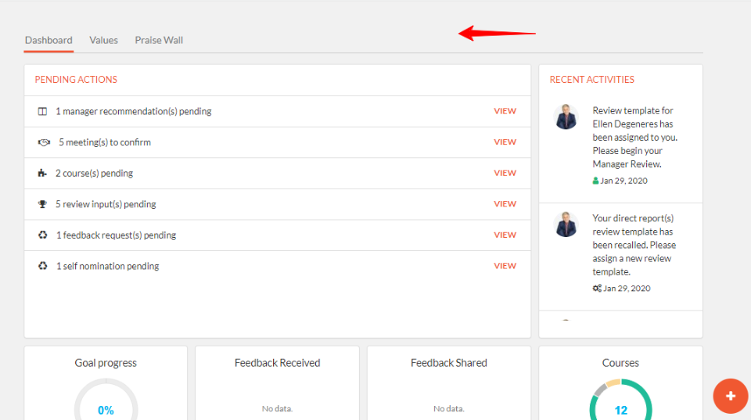

Current Color Hex Code: #F1F1F1
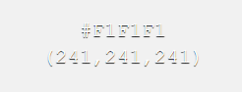

Required Color Hex Code: ????

